We will create a demo one to one mapping of the Instructor class and Instructor_details class.

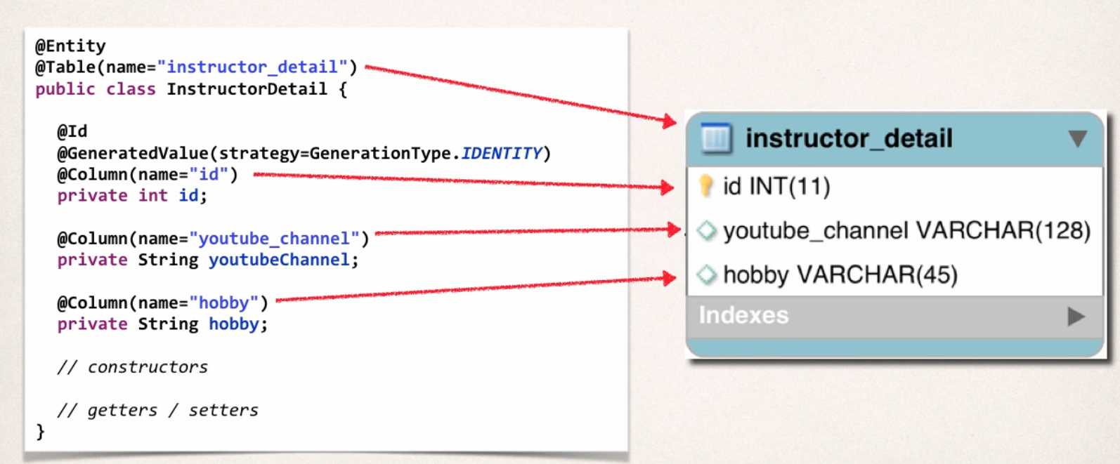

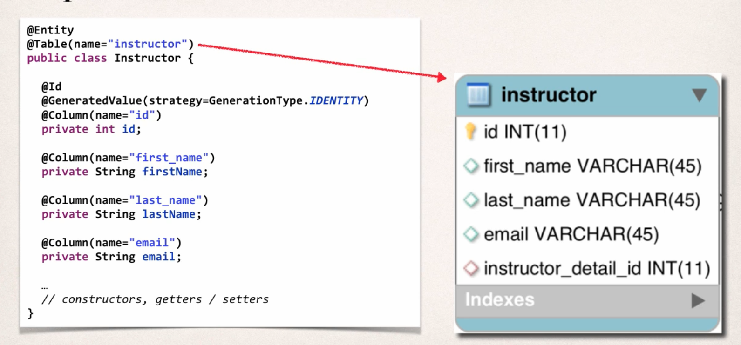

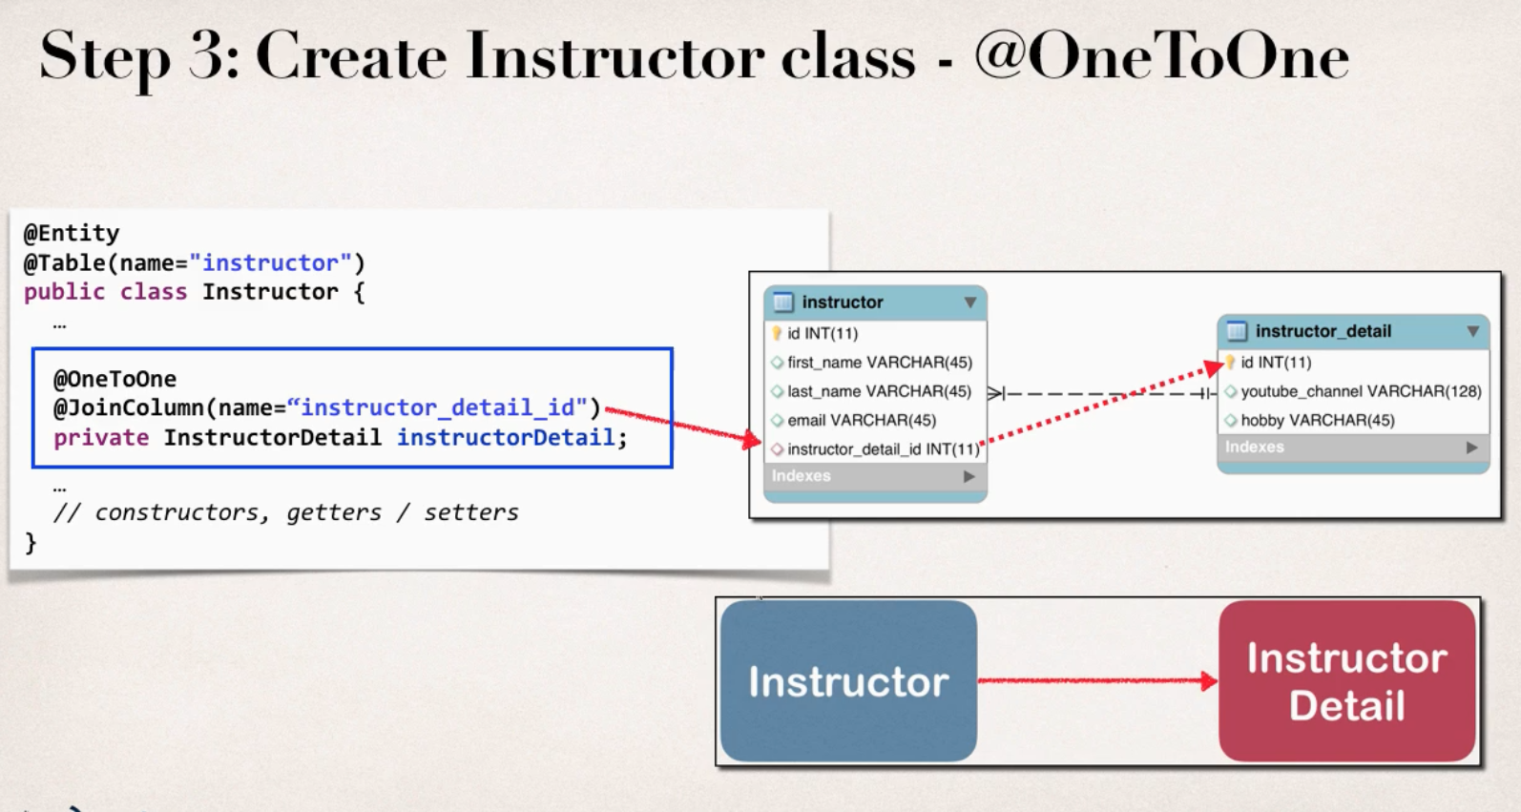

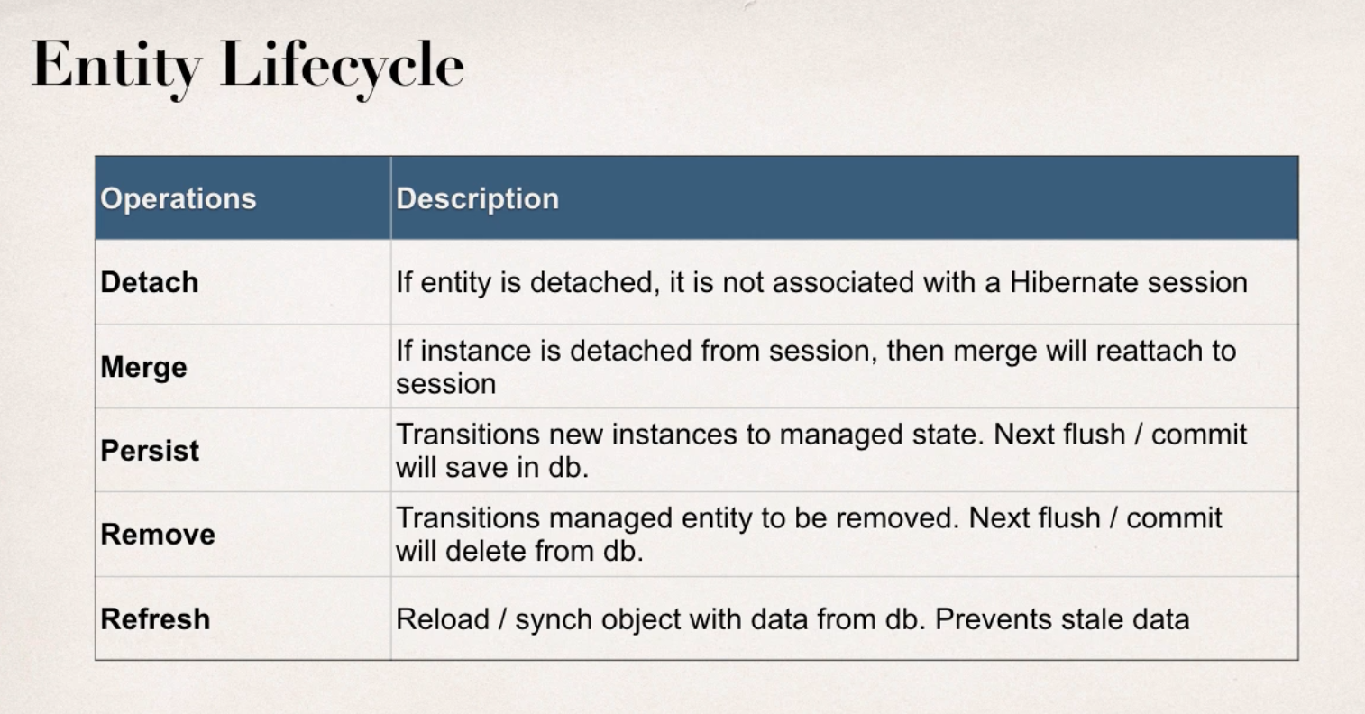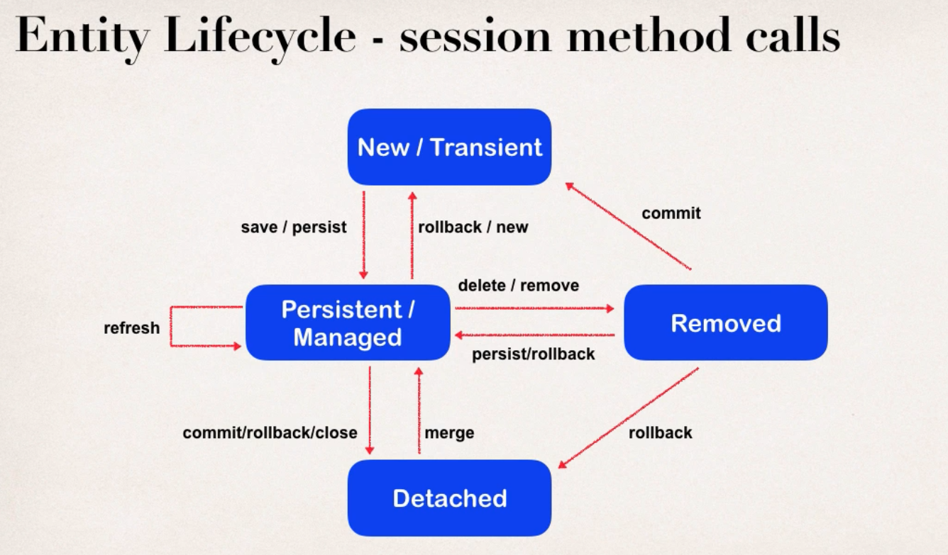

# Entity Life-Cycle

* **Transient:** 
  + The transient state is the initial state of an object.
  + Once we create an instance of POJO class, then the object entered in the transient state.
  + Here, an object is not associated with the Session. So, the transient state is not related to any database.
  + Hence, modifications in the data don't affect any changes in the database.
  + The transient objects exist in the heap memory. They are independent of Hibernate.
* **Persistent/Managed:**
* As soon as the object associated with the Session, it entered in the persistent state.
* Hence, we can say that an object is in the persistence state when we save or persist it.
* Here, each object represents the row of the database table.
* So, modifications in the data make changes in the database
* **Detached**:
  + Once we either close the session or clear its cache, then the object entered into the detached state.
  + As an object is no more associated with the Session, modifications in the data don't affect any changes in the database.
  + However, the detached object still has a representation in the database.
  + If we want to persist the changes made to a detached object, it is required to reattach the application to a valid Hibernate session.
  + To associate the detached object with the new hibernate session, use any of these methods - load(), merge(), refresh(), update() or save() on a new session with the reference of the detached object.

# Cascade Types

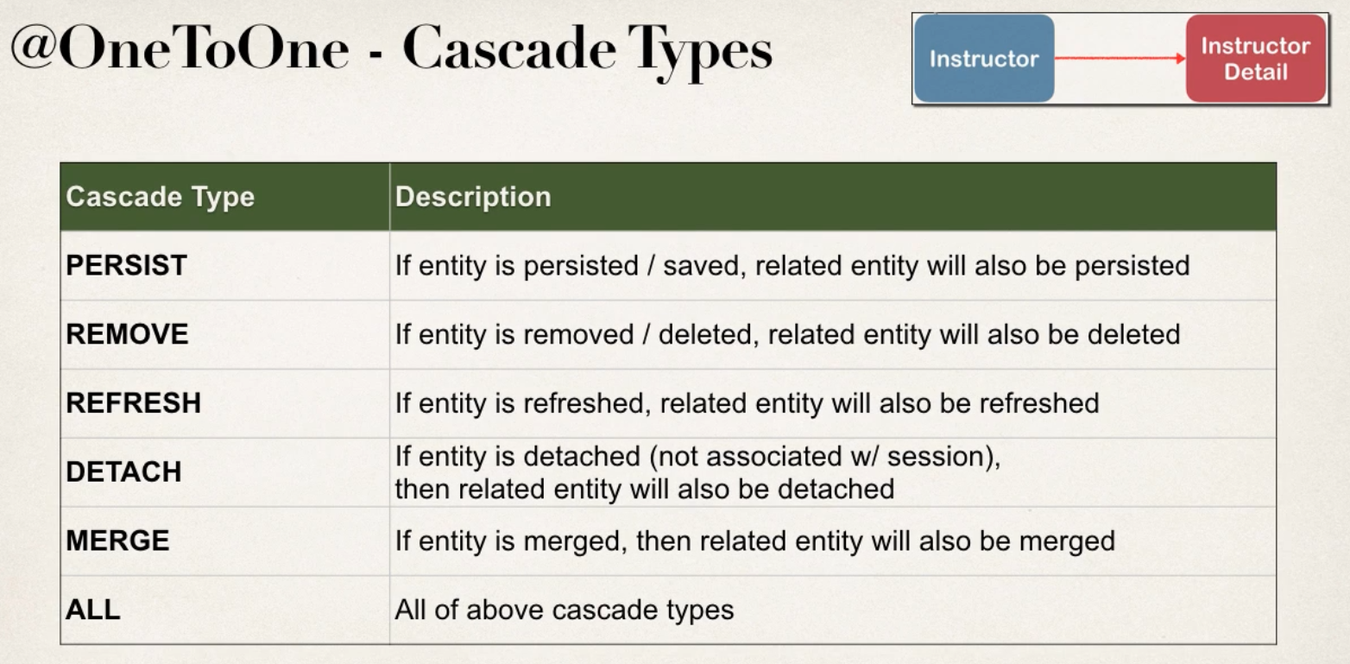

**By Default,** no operations are cascaded. So, if we want cascade operations, we have to specify it.

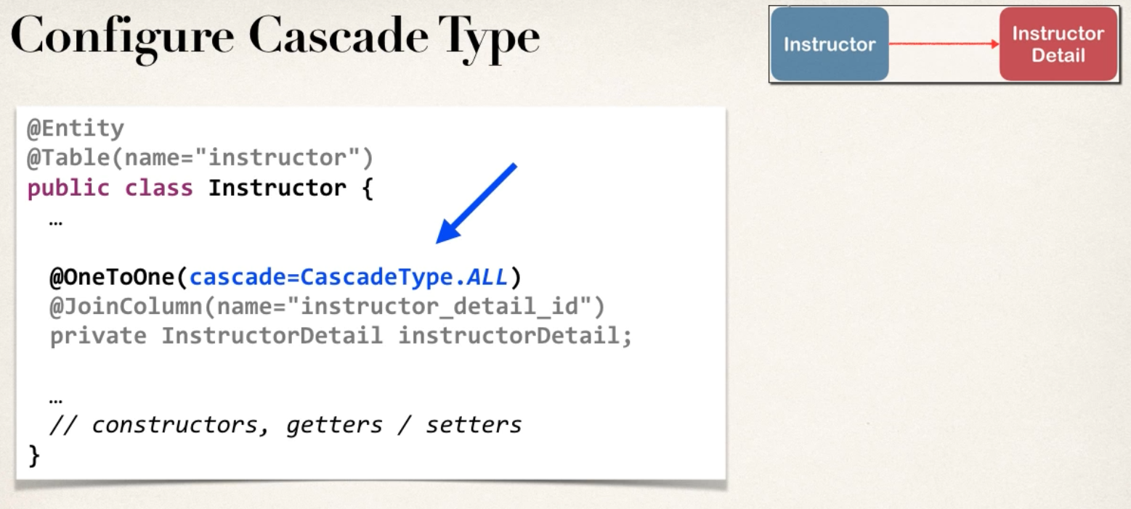 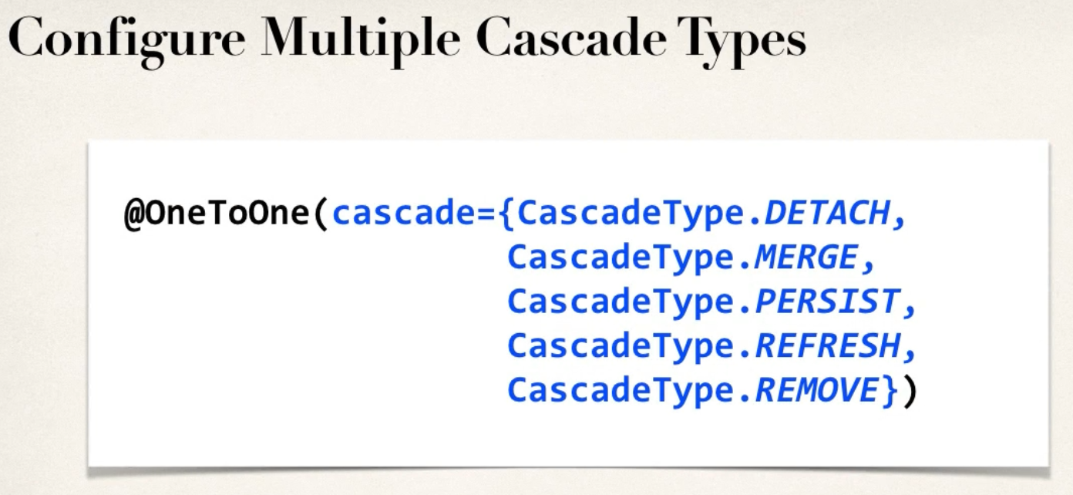

**Creating the App:**

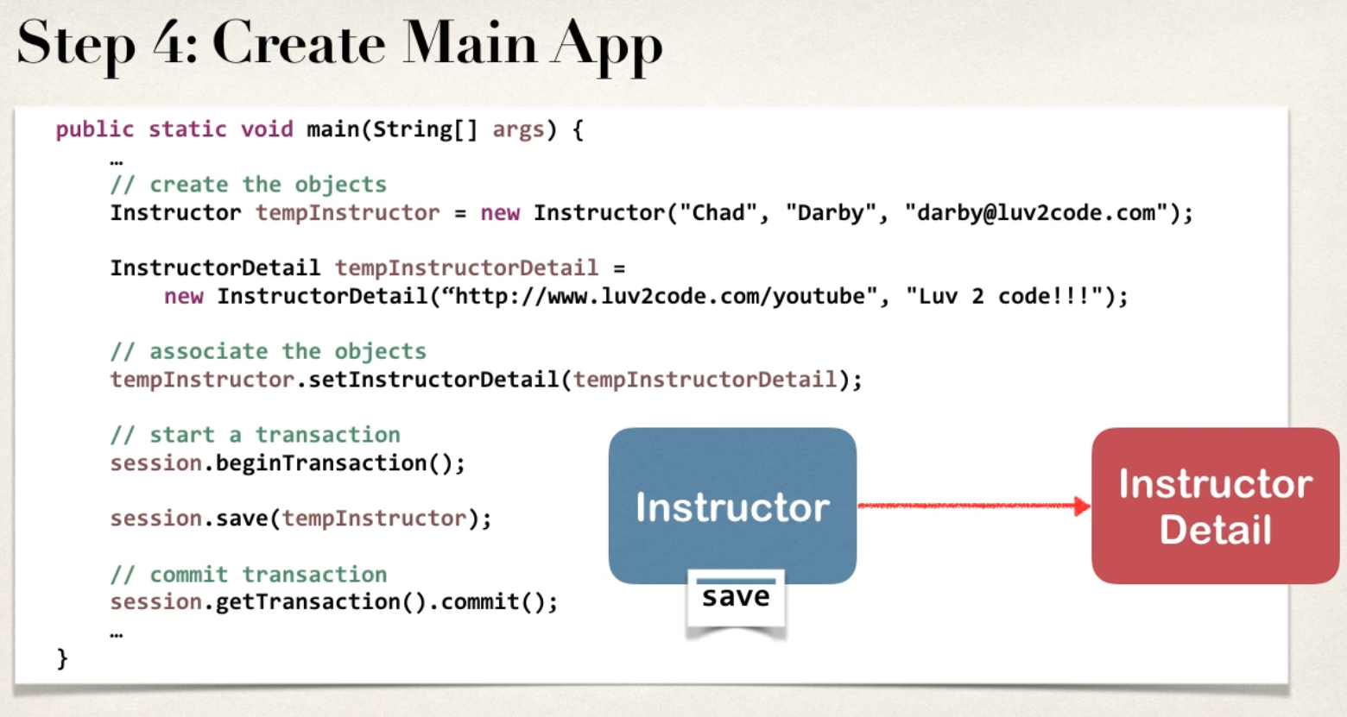

Rest of the code check on the application. The Code can be uni directional and bi directional both.

* For bi-directional, we can use the annotation **@OneToOne (mappedBy= “table name here”)**

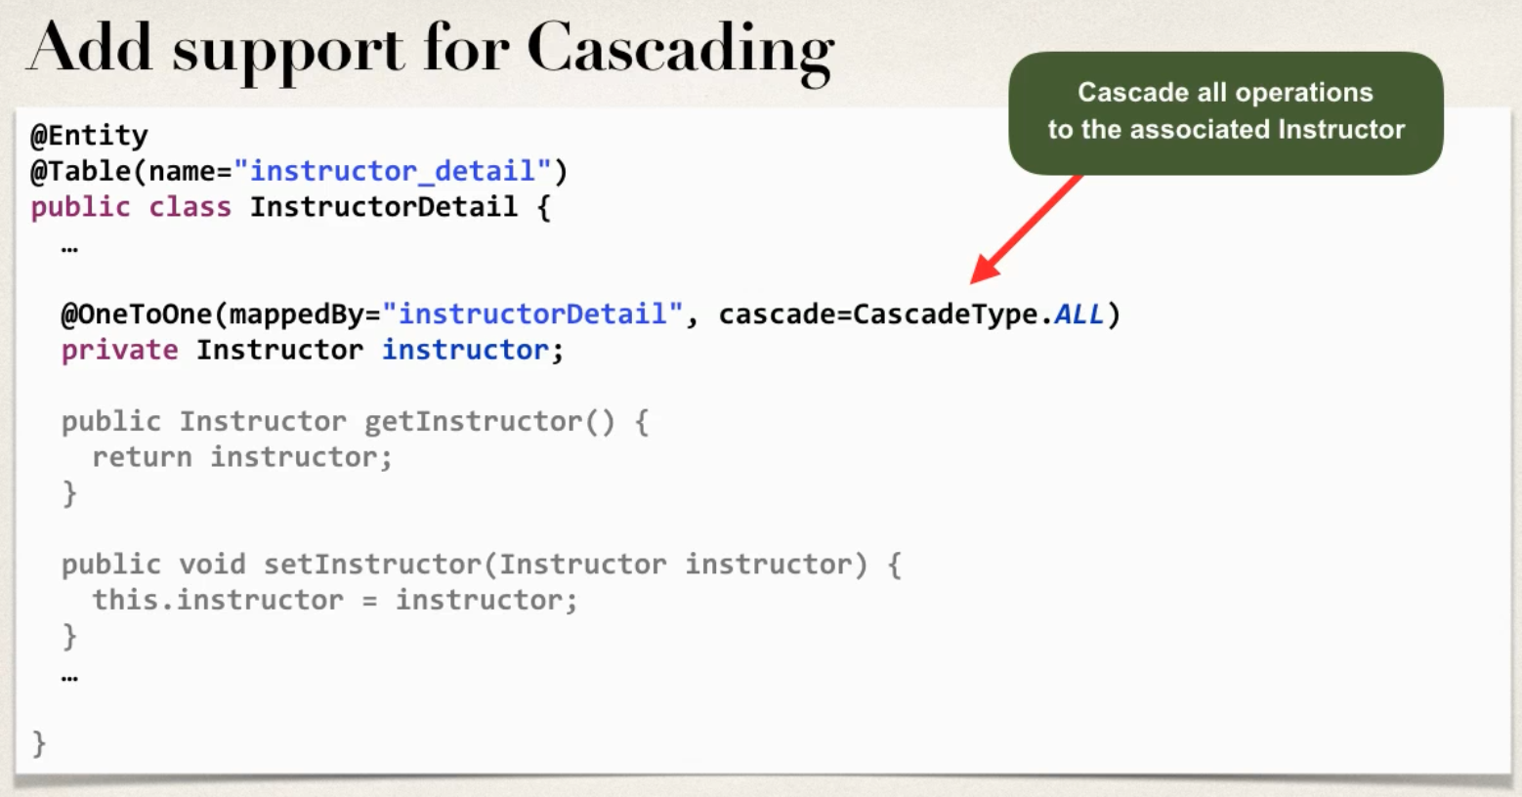

We are defining here that this instructor field is mapped by the instructor detail property in the instructor class. So this makes the relationship bi directional, as we can create a InstructorDetail and in cascade it can add the instructor.

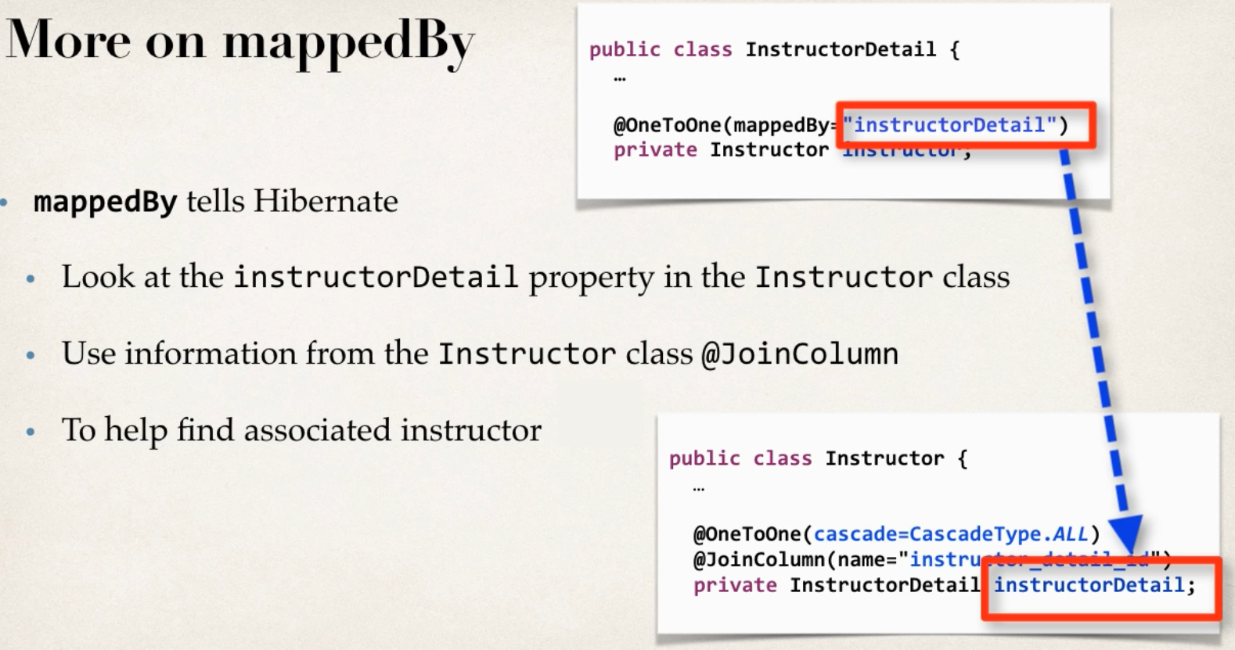

**Deleting:** For deleting we can choose to delete cascade, that will delete the row from the other table as well by cascade rule. Or we can remove the mapping by setting the value to null to the table that we want to keep the value.